Name: Mark James M. Fiel Date: 04-06-2026
Yr & Sec: BSIT 3 – B

Activity 2: UML Diagram Design Project

“Design of a Web-Based Multi-Organization Facility Reservation Management System”

- Brief System Description.
The system is a web-based facility reservation management system designed to handle booking and scheduling for multiple organizations such as school gyms, meeting rooms, barangay session hall, court and offices. Each organization operates independently within the system and it has its own administrator who manages facilities, users, and reservation requests. The system ensures that all reservations are properly monitored and prevents scheduling conflicts through automated validation.
The users within each organization can view available facilities, submit reservation requests, and track the status of their bookings. Administrators are responsible for approving or rejecting requests and maintaining the availability of facilities. The system also provides a calendar view to display scheduled reservations, making it easier for users and administrators to manage time slots efficiently.

- Actors/Users
Admin / Actors
Manages facilities
Manages users
Approves/Rejects reservations
Views schedules

User
Views facilities
Requests reservations
Views reservation status
Checks booking history
- Main System Functions
- Facility Management (Add, Edit, Delete, Activate/Deactivate)
- User Management
- Reservation Request System
- Approval/Rejection of Reservations
- Conflict Checking (Avoids double booking)
- Calendar Viewing of Schedules
- UML Diagram “USE Case Diagram”
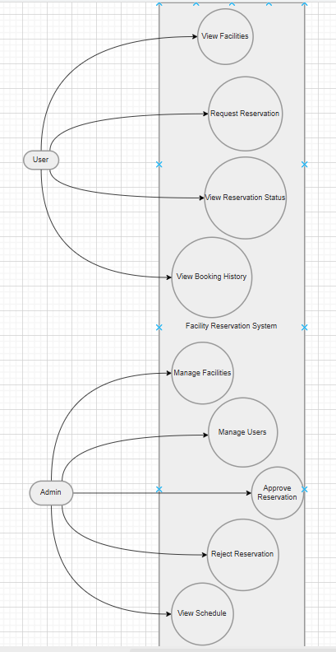

Short Explanation:
In this class diagram above this represents the structure of the facility reservation system concept that I’ve had on my mind, it shows the main classes and their relationships. The organization class will serve as the parent entity that contains the users and all facilities. The users can create a reservation for each specific facility, while each reservation stores the scheduling and its status information. The ReservationLog class is used to tack the actions that are performed on each reservation. Overall, the diagram that I have drawn illustrates how the data is organized and how the different components of the system interact with each other.

